variable type are of 2 :
value type
reference type
value type: directly hold the value
ex: all basic types, structures & Enum
reference type : hold the reference to the value on heap
ex: string, object ,class, arrays , delegates

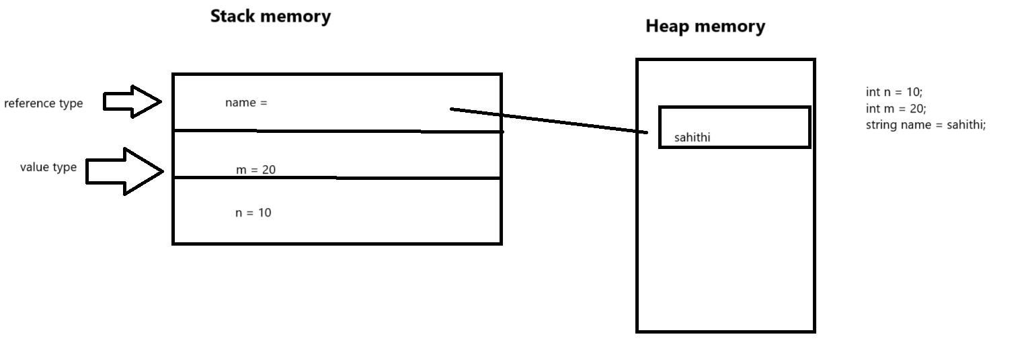

Type casting:
It is converting one form to another form.
Implicit casting :
If every possible value of RHS expression is valid for variable on LHS variables.
Explicit casting: RHS is assigned to LHS and if there is a possibility of data loss then explicit casting is needed.
Casting is based on range not on size of data type
Byte(1)
Short(2)
Int(4)
Long(8)
Decimal(16)
Float(4)
Double(8)
Decimal to anything and anything to decimal is explicitly casting.

Object data type -Boxing and unboxing
Boxing: transform [value type to object (refence type)] the object on the heap
Unboxing: transformation from object to value type. we use the term casting here as this has to be done explicitly.
